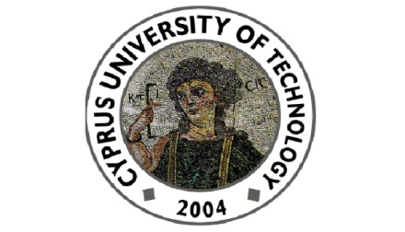

Cyprus University of Technology
Department of Commerce, Finance and Shipping

Seminar Talk
Thursday 15th of October 2015, 12:00 – 13:00
(Conference Room, 2nd floor, Continental Building)

“Creditor Control Rights and Board Independence”
by
Prof. Daniel Ferreira
(London School of Economics)

Abstract

We find that the number of independent directors on corporate boards increases by about 25% following violations of financial covenants in bank loans. This change in board composition appears to be a response to creditor intervention following covenant violations. In contrast, financial distress and poor financial performance at the time of covenant violations do not explain the results. We conclude that board composition endogenously responds to changes in the allocation of control rights.

Department of Commerce, Finance and Shipping
115, Spyrou Araouzou Street, 3606, P.O.Box. 50329, 3603, Lemesos
Tel. 25002489 Fax. 25002637 Email. cfs.seminars@cut.ac.cy

