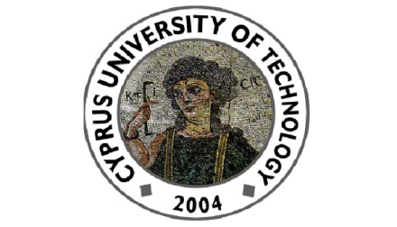

Cyprus University of Technology
Department of Commerce, Finance and Shipping

Seminar Talk
Thursday 22nd of October 2015, 12:00 – 13:00
(Conference Room, 2nd floor, Continental Building)
“The Political Ideologies of Business Leaders: Implications for Firm Practices”
by
Prof. Don Hambrick
(Penn State University)
Abstract
This article examines the influence on organizational outcomes of CEOs’ political ideology, specifically political conservatism vs. liberalism. We propose that CEOs’ political ideologies will influence their firms’ corporate social responsibility (CSR) practices, hypothesizing that (1) liberal CEOs will emphasize CSR more than will conservative CEOs; (2) the association between a CEO’s political ideology and CSR will be amplified by a CEO’s relative power; and (3) liberal CEOs will emphasize CSR even when recent financial performance is low, whereas conservative CEOs will pursue CSR initiatives only as performance allows. We test our ideas with a sample of 249 CEOs, measuring their ideologies by coding their political donations over the ten years prior to their becoming CEOs. Results indicate that the political ideologies of CEOs are manifested in their firms’ CSR profiles. Compared with conservative CEOs, liberal CEOs exhibit greater advances in CSR; the influence of CEOs’ political liberalism on CSR is amplified when they have more power; and liberal CEOs’ CSR initiatives are less contingent on recent performance than are those of conservative CEOs. In a corroborative exploration, we find that CEOs’ political ideologies are significantly related to their corporate political action committee (PAC) allocations, indicating that this largely unexplored executive attribute might be more widely consequential.

Department of Commerce, Finance and Shipping
115, Spyrou Araouzou Street, 3606, P.O.Box. 50329, 3603, Lemesos
Tel. 25002489 Fax. 25002637 Email. cfs.seminars@cut.ac.cy

